The UR-105 CT

URWERK in a New York state of mind

September 2017.

URWERK is 20 years old! A time to look back over our shoulder, not with nostalgia or regret, but to recapture a sense of excitement. It was 20 years ago that 22-year-old Felix Baumgartner set foot in New York, where Martin Frei had made his home. It was vibrant, noisy and thrilling, a giant playground of fantasy and tension. Today they evoke that mix of emotions in their new creation, the UR-105 CT *Streamliner*.

Let’s take you on the ride!

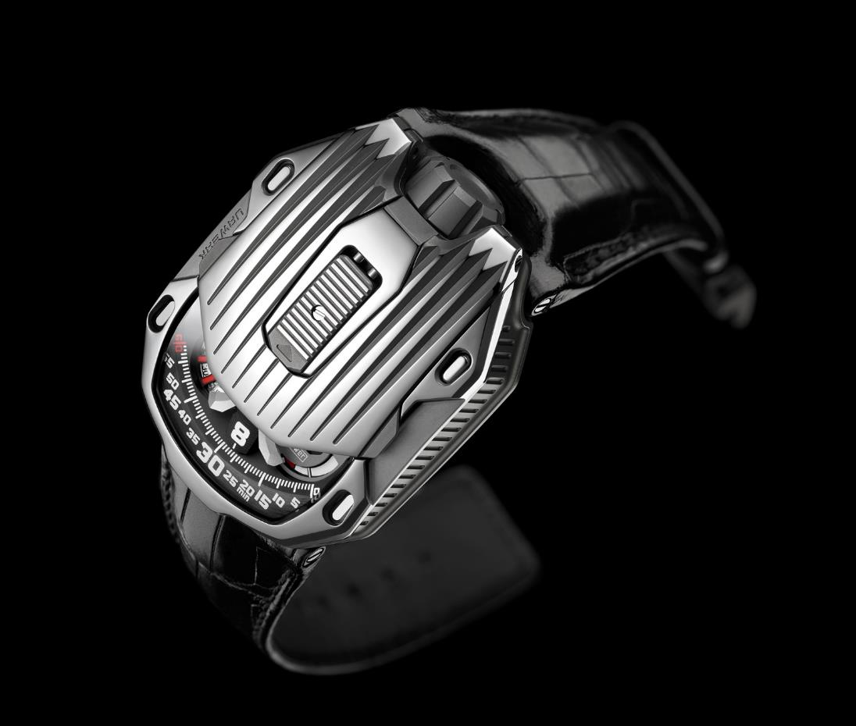

In March 1997, Martin Frei graduated from the College of Arts and Design in Lucerne (Switzerland), and moved to New York where he joined other Swiss artists in founding the United Swiss Artists (USA) association. He was then living in Brooklyn — in a garret that soon became a creative hub.

Felix was in Geneva, Martin across the Atlantic. Their brainchild, URWERK, had been born but was struggling to take its first steps. The UR-101 and UR-102 were critically acclaimed but the company wasn’t viable. Its founders just managed to keep it above water amid increasing misgivings. What did the future hold for URWERK? Should they persist with a dream that was eating up all their savings? With these questions in mind, Felix took a plane to New York to join his friend. Felix Baumgartner was 22, Martin slightly older. Together in the city of their dreams they wandered the streets, taking in the images of New York, its redbrick houses, its Art Deco skyscrapers and gleaming subway. These pictures filled their minds and would never leave them.

Twenty years have now gone by and URWERK is an established niche brand. Their dream has taken shape and come to life. And when Martin Frei and Felix Baumgartner look back to those days, their memories return on the drawing board and the workbench. Their American dream is now on their wrists as the UR-105 CT *Streamliner*.

The UR-105 CT is first of all a beautiful object that fits snugly in the palm of your hand. Its unique shape is a remarkable octagon with deep grooves along its length. The Art Deco influences are apparent in its geometric angularity and symmetry. As Martin Frei explains, “the *Streamliner* has a minimalist design with few frills and clean lines. In the initial drawings, I thought of the Empire State, the Chrysler and the Comcast buildings. That is why it has that vertical structure that seems to go on forever.”

You have to slide the catch on the top of the case to reveal the mechanism of the UR-105 CT. It’s a new wandering hour indication based on an openwork carousel, which carries the four satellites, each bearing three numerals for the hours. The hours successively sweep past the minutes scale for an analogue and digital display of the time. According to Felix Baumgartner, *Streamliner* is an apt name for this watch. “The UR-105 CT is a watch with a flexible design. When it is closed, it looks austere, with only the time indication visible. Open the protective cover and you delve into a metallic environment that is quite cold, yet you perceive a notion of speed and an effort at efficiency. The *Streamliner’s* carousel has been completely redesigned, becoming lighter, stronger and far more effective.”

A power-reserve indicator and digital seconds make up the rest of the information displayed on the dial. The digital seconds are remarkable in that they indicate tens of seconds. The mechanism was made using a photolithographic process, with each marker openworked to make it as light as possible. It thus weighs less than a tenth of a gram.

Two pneumatic turbines on the back govern the selfwinding rate, which can be set with a lever. In the FULL position, the slightest movement of the wrist is harnessed to rewind the barrel spring. Turn the lever to STOP to disengage the selfwinding system and wind up the UR-105 using the crown. An intermediate position, RED (for reduced) engages the turbines to dampen the winding rotor and avoid overstressing the mainspring, if you are particularly active.

In the *Streamliner*, Felix Baumgartner and Martin Frei take you to the New York of their youth, a plunge into a city of different facets, from the top of the highest skyscraper to the depths of the subway.

*In New York  
Concrete jungle where dreams are made of  
There's nothing you can't do  
Now you're in New York  
These streets will make you feel brand new  
Big lights will inspire you  
Let's hear it for New York, New York, New York*

*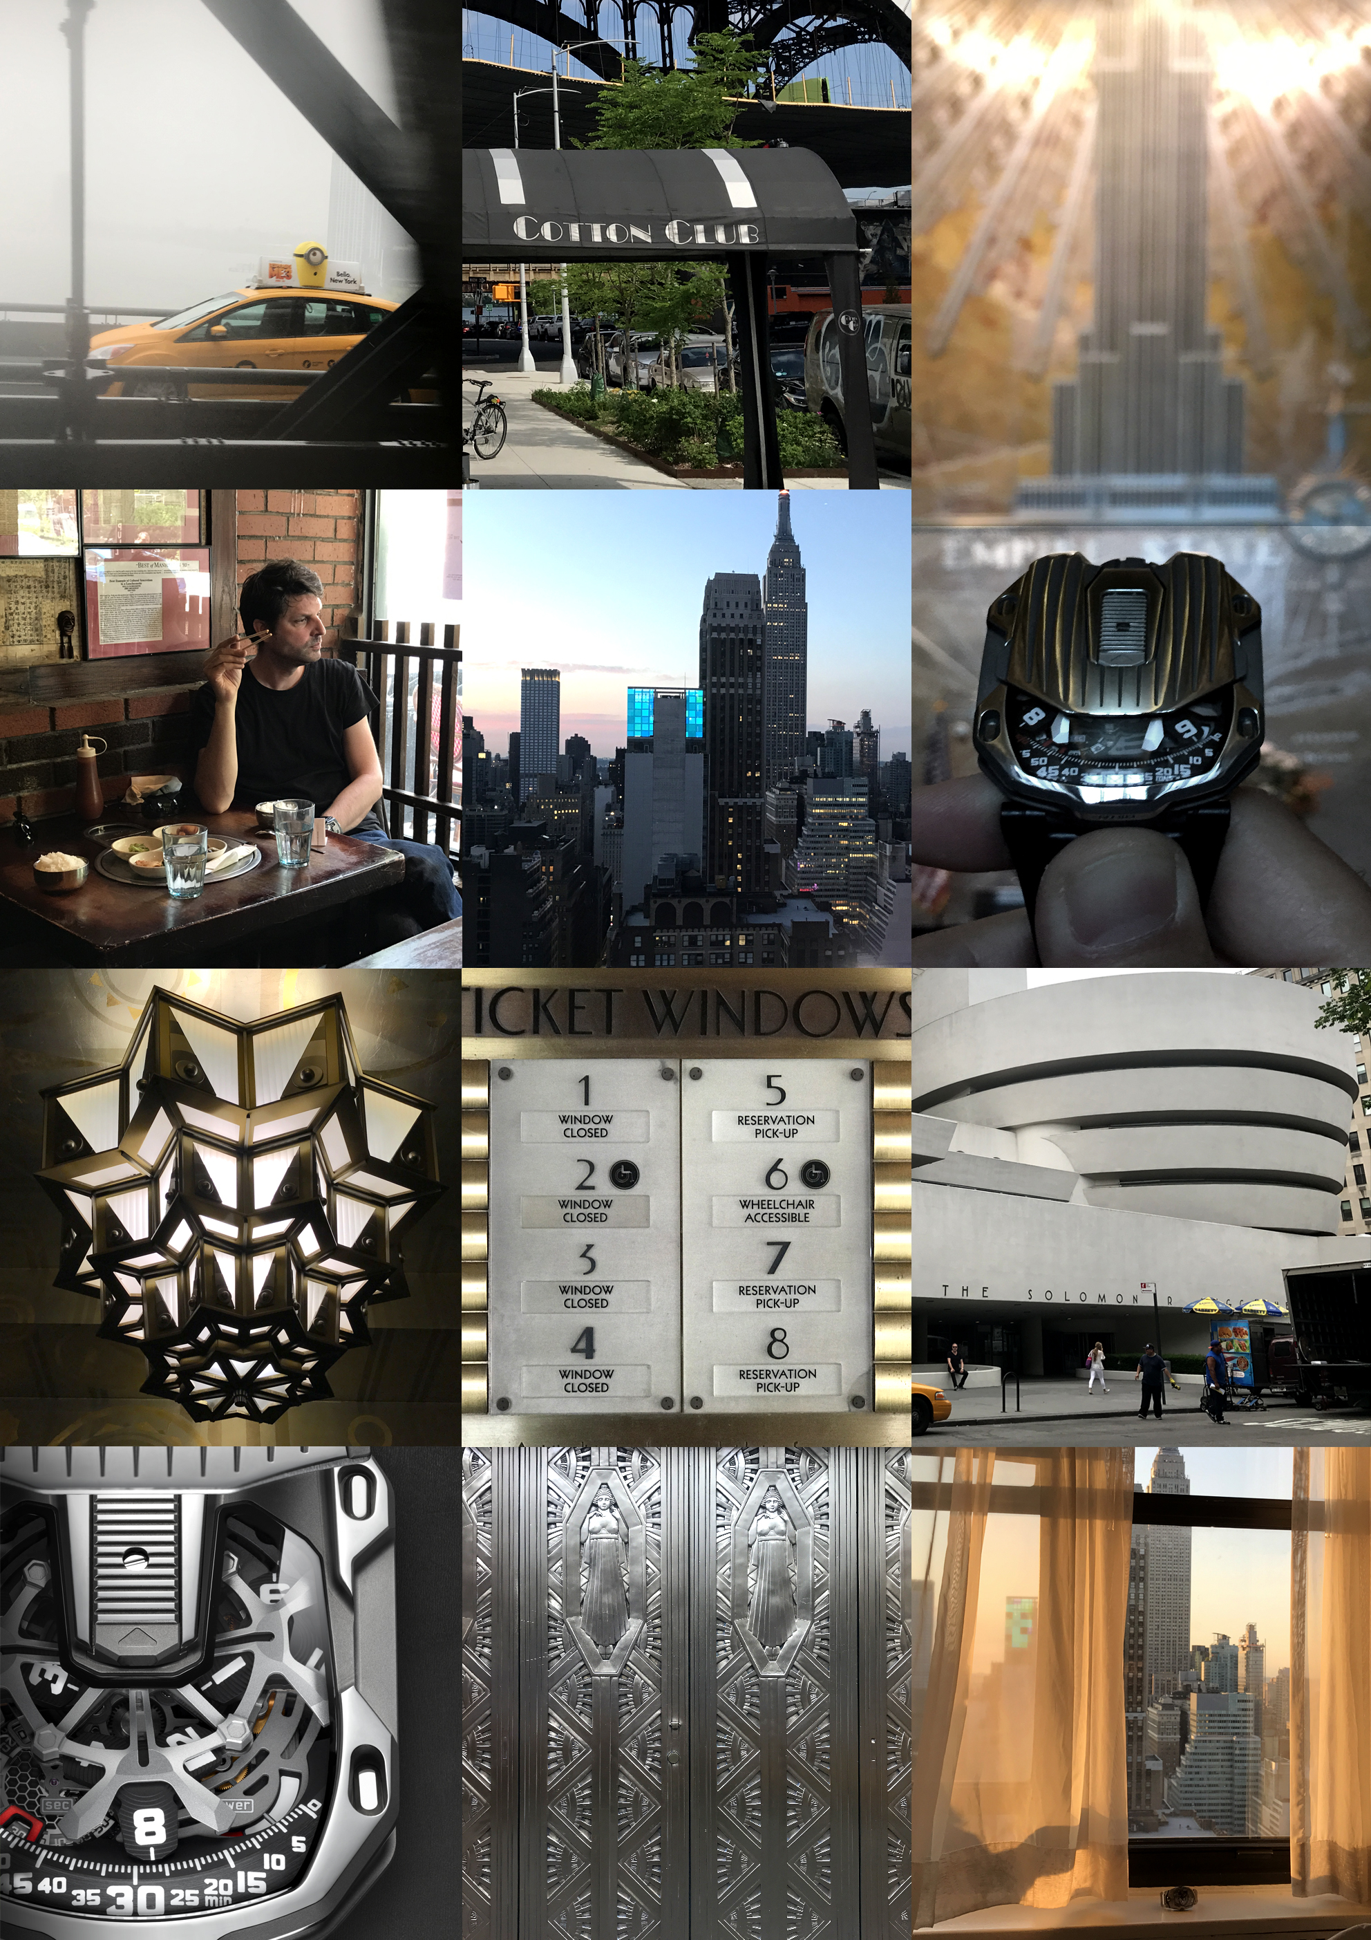©Jay-Z*

**UR-105 CT *Streamliner* – Specifications**

The *Streamliner* comes in two versions:

Titanium and mirror-polished steel (CHF 65’000.00 – Swiss francs / tax not included)

Titanium and black PVD coated steel (CHF 65’000.00 – Swiss francs / tax not included)

|  |  |
| --- | --- |
| **Movement** |  |
| Calibre: | UR 5.03 with the selfwinding system governed by twin turbines |
| Jewels: | 52 |
| Frequency: | 28,800v/h - 4Hz |
| Power reserve: | 48 hours |
| Materials: | Satellite hours turning on Geneva crosses in beryllium bronze; openworked aluminium carousel; openworked digital seconds; carousel and triple baseplates in ARCAP |
| Finishes: | Circular graining, sanding, brushing  Chamfered screw heads  Hours and minutes painted in SuperLuminova |
|  |  |
| **Indications** | Wandering hours; minutes, digital seconds  Power reserve |
|  |  |
| **Case** |  |
| Materials: | UR-105 CT in titanium and mirror-polished steel  UR-105 CT black in titanium and PVD coated steel |
| Dimensions: | Width 39.5mm; length: 53mm; thickness: 17.3mm |
| Glass: | Sapphire crystal |
| Water resistance: | Pressure tested to 3ATM (30m) |

___________________

Media contact:

Ms Yacine Sar press@urwerk.com

Tel +41 22 9002027 cellphone +41 79 834 4665

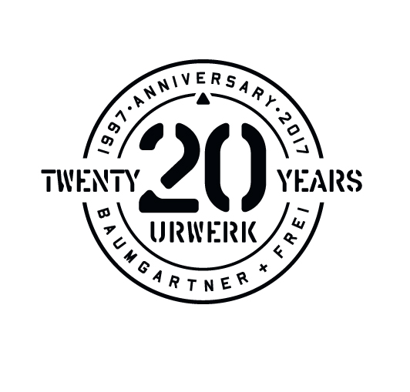

ABOUT URWERK

“We don’t try to bring out new versions of existing complicated mechanisms,” explains watchmaker Felix Baumgartner, co-founder of Urwerk. “Our watches are unique because they are all designed as original works, which makes them rare and priceless. Our main aim is to go beyond the traditional horizons of watchmaking.” The original styling of each Urwerk model is signed by chief designer Martin Frei, the company’s other co-founder. “I come from a background where creativeness has no limits. I am in no way prisoner of the traditional constraints of watchmaking, and I can therefore be freely inspired by my cultural heritage.”

Although Urwerk is a young company established in 1997 (already 20 years old!) it is recognised as one of the forerunners of the new wave known as *nouvelle horlogerie*. Producing just 150 watches a year, the company sees itself as a craftsman’s studio where traditional expertise coexists with avant-garde styling. The company manufactures modern and complex watches that are unprecedented and in keeping with the most demanding criteria of fine watchmaking: independent design and research, advanced materials and handcrafted finishes.

The name Urwerk comes from the ancient city of Ur of the Chaldees in Mesopotamia, founded nearly 6,000 years ago where the Sumerian inhabitants first established units of time based on the shadows cast by its monuments. *Ur* in the German language also means primeval or original and *Werk* means an achievement or a mechanism. Thus Urwerk can be translated as an original movement — a tribute to generations of watchmakers whose work has resulted in what we know today as *haute horlogerie*, or superlative watchmaking.

[www.urwerk.com](http://www.urwerk.com)