The UR-110. Ten years ... and time to say goodbye.
Geneva – October 7, 2021
"While we are not the nostalgic kind here at URWERK, we are proud to be celebrating the 10th anniversary of our 110 collection. This is a creation that won the Best Design prize in the Grand Prix d’Horlogerie de Genève; that faced evil on the wrist of IronMan, the most badass Superhero of them all; and that made the cover of major watchmaking magazines at the time of its launch in 2011. It needed to complete one last mission before it slipped away, so we are going to issue a final UR-110 in bakelite. A one-of-a-kind model that will be auctioned off on our dedicated website, with most of the proceeds going to the Swiss Red Cross", said the two URWERK founders, Felix Baumgartner and Martin Frei.

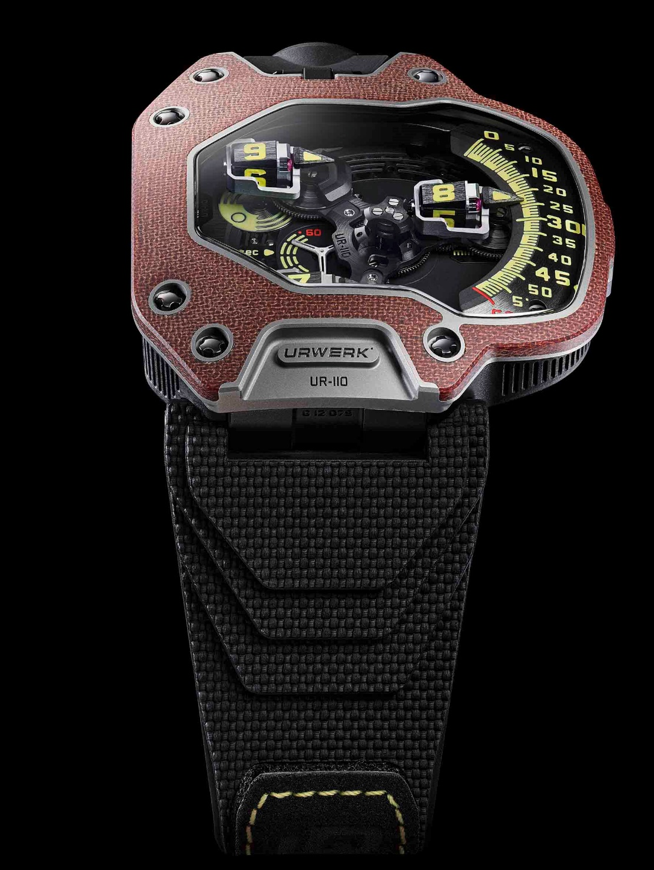
The UR-110 will therefore be retiring exactly 10 years after its birth – and doing so in style, on behalf of a worthy cause. This one-off UR-110 Bakelite will be unveiled on 10/10 at 10:10 a.m. Geneva time on the https://urwerkpreowned.com/website.

The UR-110 Bakelite features a titanium case and an original bezel made of bakelite, a star material from the 1900s. As Felix Baumgartner explains: "Bakelite was one of the first high-tech materials ever developed. Its properties were and remain multiple and revolutionary. Insulating and heat-resistant, it was present in all everyday objects at the time, from eyeglass frames to radios”, Felix Baumgartner.

A couple of dates: The UR-110 Bakelite will be revealed on 10.10.2021 at 10:00 am Geneva time. The auction will start on October 15th and will close on 17.10.2021 at 10:00 am Geneva time.

Technical specifications UR-110 Bakélite. One-of-a-kind model

Movement
Calibre: UR 9.01 mechanical, automatic winding
Balance: Monometallic
Jewels: 46
Frequency: 28,800v/h, 4Hz
Balance spring: Flat
Power: Single barrel
Power reserve: 39 hours
Winding system: Uni-directional rotor regulated by double turbines
Finish: Matting, circular graining and diamond-cuts

Indications
Satellite complication with rotating hour/minute modules mounted on planetary gears
Control Board: “Day/Night” indicator; “Oil Change” alert for service intervals and small seconds

Case
Case in Grade 5 titanium with bezel in Bakélite
Dimensions : 47mm X 51mm X 16mm
Two-position crown with integrated protection.
Water resistance: tested to 3 ATM

Press contact:
Ms Yacine Sar
press@urwerk.com
+41 22 9002027
www.urwerk.com/press

